Stuck in the postdoc swamp
In November, the Danish Ministry for Research and Education will redraft the law regulating the staff structure at Danish public research institutions, including universities. You can find the link to the proposed redraft and opinions issued by different Danish institutions at the end of the document.
The primary role of the university is to conduct research and to deliver research-based teaching, and it is essential that the official staff structure reflects and supports this aim. The staff structure, as set out by the ministry, defines a clear career path from assistant professor/researcher to full professor level, and describes the expected role that each level will play in executing the responsibilities of a university.
The current structure, however, does not include staff between the PhD level and the level of assistant professor/researcher in the academic career pathway. Positions, such as “postdoc”, stand to be classified as “other, general positions” in the redrafted law. Hence, those employees are left without any clearly defined career path.
We also note that the term “Junior Researcher” does not exist in the current staff structure and is not mentioned in any documents that propose future amendments to the staff structure. The term “Junior Researcher” was proposed by AU management in response to a perceived problem in staff development and talent retention. That is, the risk that talented researchers are lost by the university to other sectors, such as industry, or to emigration.
The lack of a defined career path for JRs has coincided with a ballooning in the number of researchers employed at this career level.
There are four main reasons for an increased number of JRs:
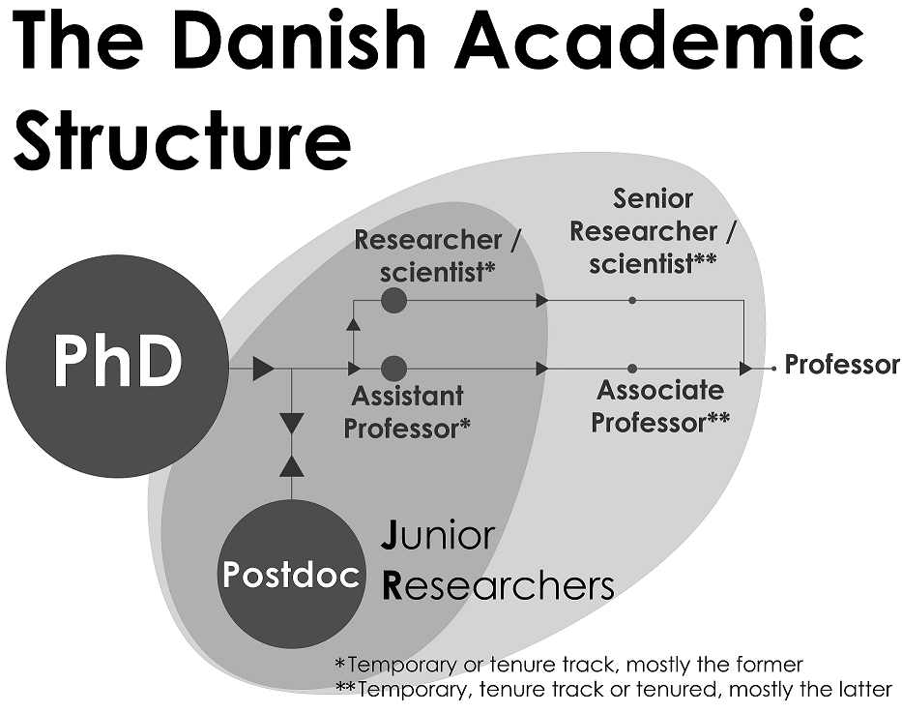
The law that regulates the staff structure at Danish public research institutions is due for renewal. This will have direct consequences for the career paths of junior researchers.
i) Over the last decade, there has been a large increase in the number of PhD students graduating from Danish universities. A large number of those candidates move onto temporary research-position contracts at universities. The number of postdocs and assistant professors has risen by 94% from 2007 to 2015 (Ministry of Education and Research, 2019);
ii) The ratio of permanent staff members to students has dropped dramatically in the last decade. The influx of PhD students, for example, was not matched by a similar increase in permanent staff to cater for the increased teaching load. This created a need for additional skilled personnel, mostly filled by temporary research staff;
iii) The ratio between hard money, defined as government funding guaranteed to a university, and soft money, defined as money won through competitive grant application processes, has dropped in the last decade. Universities tend to use these funds to hire employees on temporary contracts.
And finally, (iv) A divergence between the perceptions of JRs and the reality at Danish research intuitions. The perception might be that JR positions are created to populate universities with permanently employed, skilled research and teaching staff; While the reality is that 90% of JR positions are created with the intention of moving the holder out of academia.
The perceived problem of failing to capitalize on the talent hidden in the junior researcher pool has a better description as the “postdoc swamp”. The institutions governing research management and development in Denmark have a responsibility to assist these employees as they strive to reach their career goals. By no means is this problem restricted to Denmark, it is a global phenomenon.
The consequences of this lost research talent are a lack of diversity at the senior researcher level at Danish institutions, that is, the permanent staff level to whom the current staff structure applies; and a frustrated and demotivated population living in the “postdoc swamp”.
JRs need to develop an exit strategy for research positions outside of academia, and the university needs to improve the framework that qualifies and prepares their temporary academic staff for this transition. The numbers of JRs employed at a University needs to correlate better to the number of permanent positions available. And finally, the pathway from a postdoc position to an academic position needs to be presented in a transparent way, so that the decision to enter the swamp is a conscious decision.
_______________________________________________________________________________________
The Junior Researcher Association would like to raise public awareness and comment on the proposed laws by publishing a newspaper article on this topic. If you are interested in discussing these issues, contact the JRA through their website https://talent.au.dk/junior-researcher-development-programme/the-junior-researcher-association/
useful links:
The white paper describing the new Stillingsstruktur for videnskabeligt personale ved universiteter

